Chapter 7 Sampling Distributions and the Central Limit Theorem

* 7.1 Introduction

*A* ***statistic*** *is a function of the observable random variables in a sample and known constants.*

Ex. sample mean‾Y , the sample variance S2, Y(n) = max(Y1, Y2,...,Yn), Y(1) = min(Y1, Y2,...,Yn).

Because all statistics are functions of the random variables observed in a sample, all statistics are random variables. Consequently, all statistics have probability distributions, which we will call their **sampling distributions**.

* 7.2 Sampling Distributions Related to the Normal Distribution

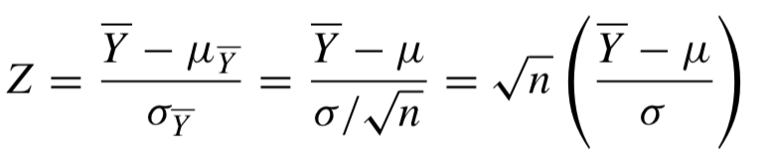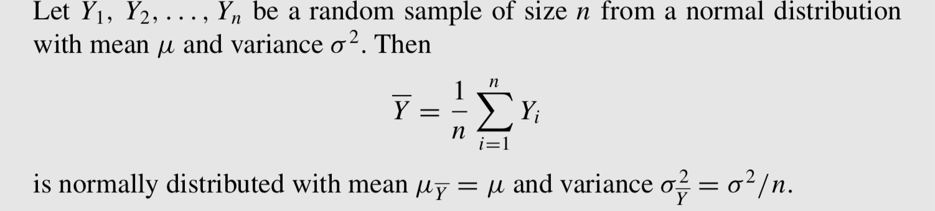

has a standard normal distribution

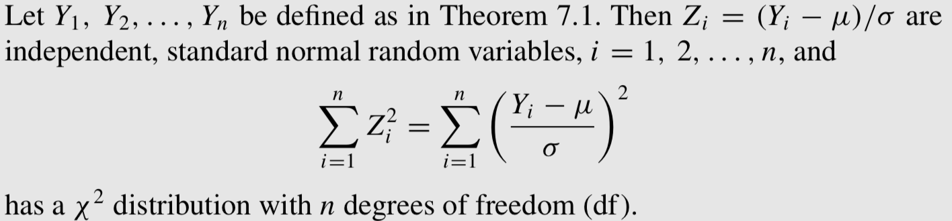

<Theorem>

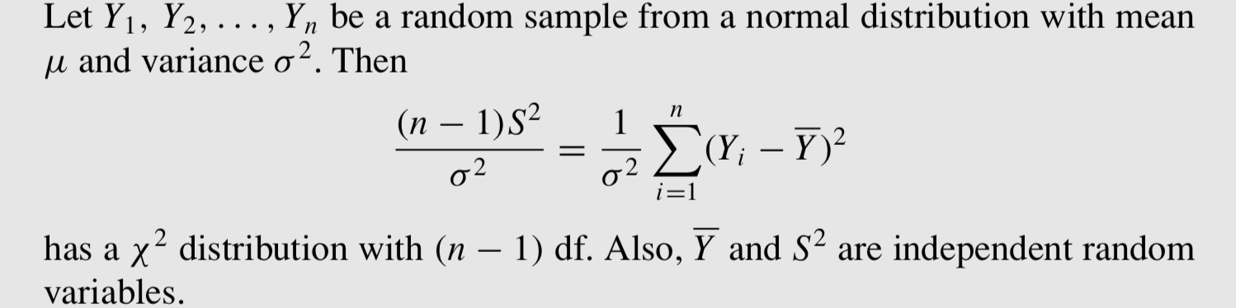

<Theorem>

